**UNIVERSITY OF BRIDGEPORT**

**Summer - 2017**



**Project Report**

**Hospital Management System Project**

**Tutor: Prof. A.Abuzaneid**

**Namrata Jagannath - 1017672**

**Srujan Kavane - 1017736**

**TABLE OF CONTENTS**

**Sl.No Description**

1 Project Report

2 EER Diagram for the Hospital Management

3 Hospital Management Working Screenshots

4 Conclusion

1. **Project Report:**

The Hospital Management System is developed in Bash Shell Programming with multiple tables creating a database with 10 records in each table. Once the database is created, the menu driven reports will be generated. Here we need to select particular option from the menu and execute the reports.

**2.EER Diagram for the Hospital Management:**

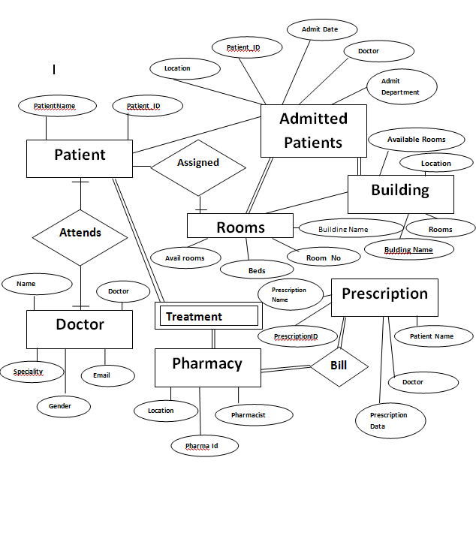

1. **Hospital Management Table List and Data:**
2. Hospital Management Menu.

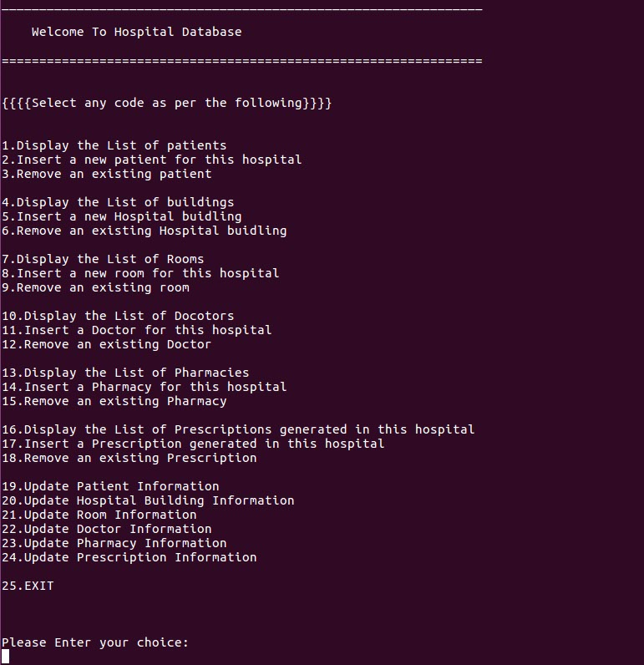

1. View the list of patients.

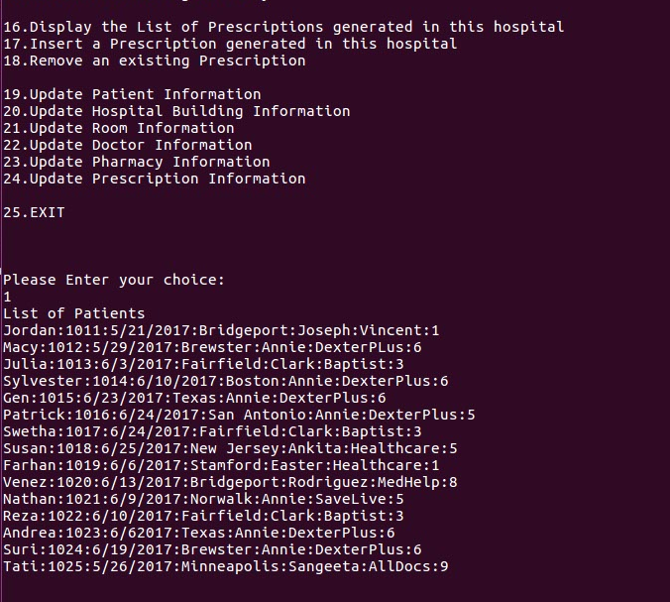

1. Adding new patient

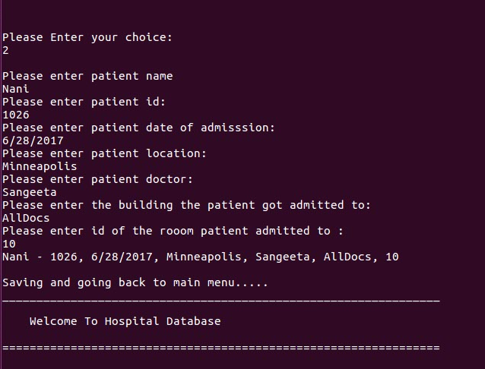

1. Deleting a Patient.

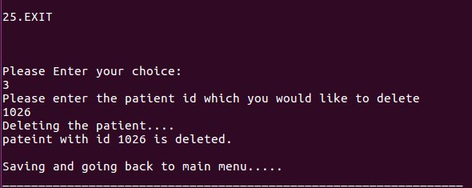

1. View the list of Buildings

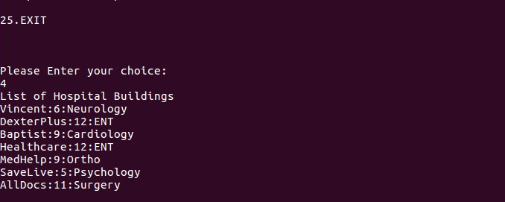

1. Inserting new building

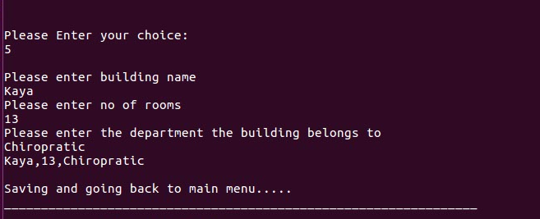

1. Deleting a building

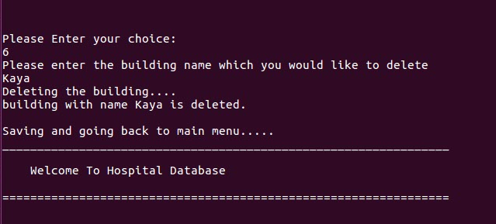

1. List of rooms

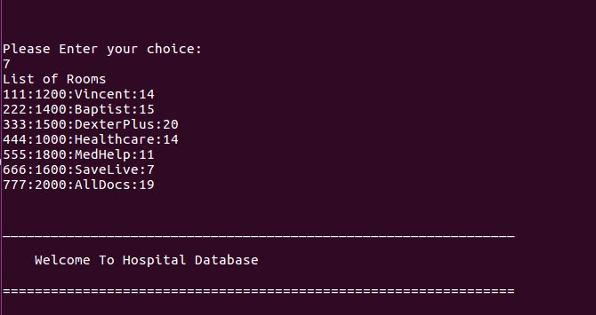

1. Add a new room

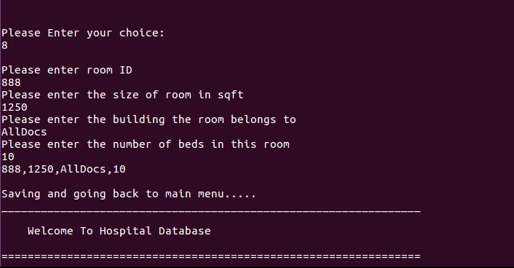

1. Delete a room

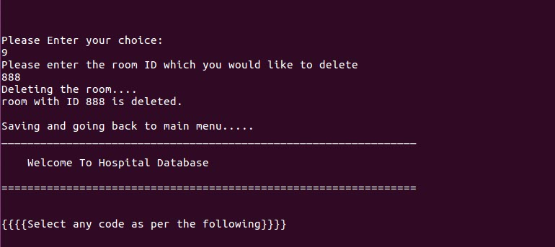

1. List of Doctors

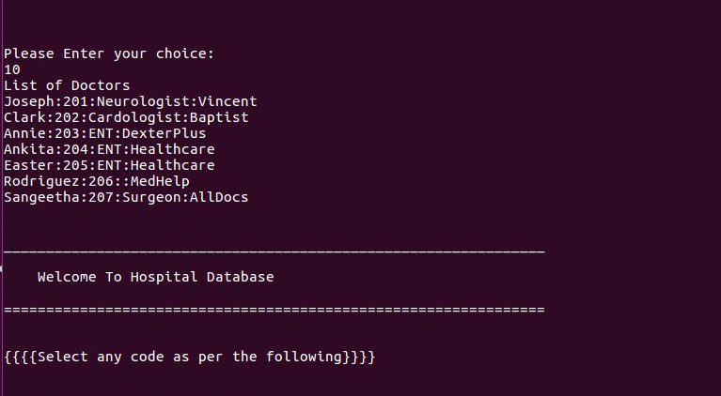

1. Insert Doctors

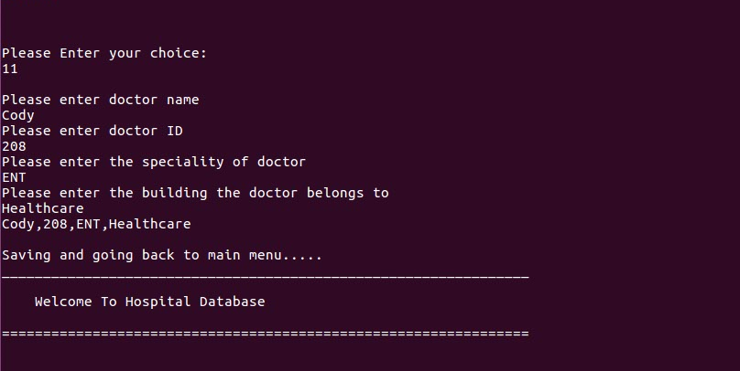

1. Delete Doctors

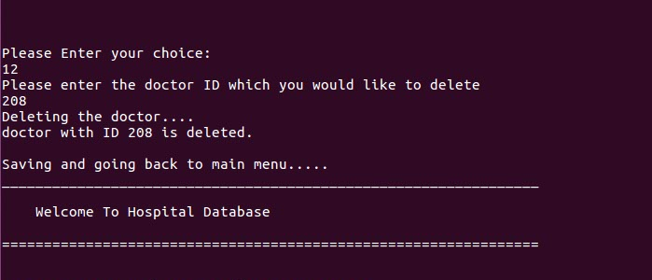

1. List of pharmacy

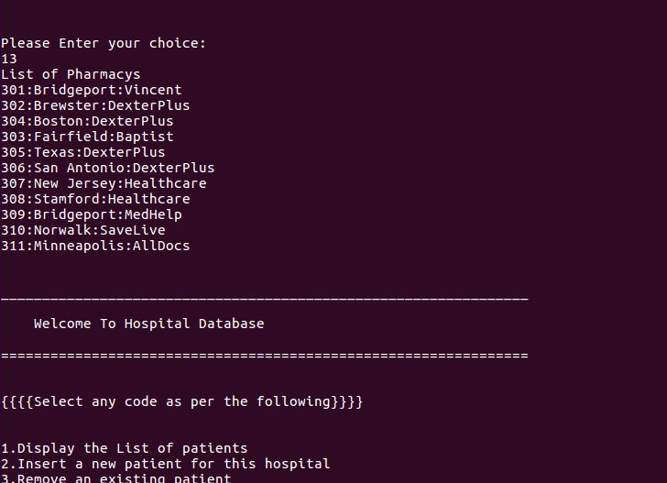

1. Insert pharmacy

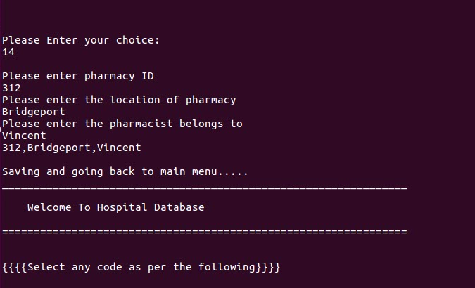

1. Delete a pharmacy

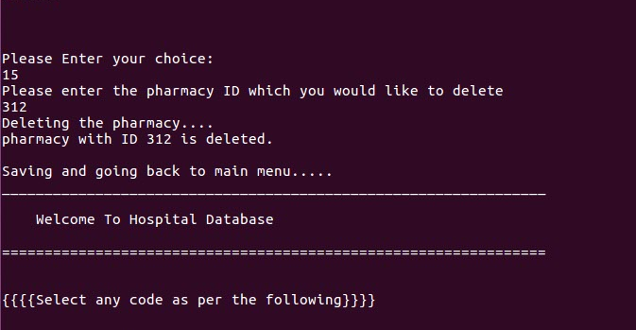

1. List of prescriptions

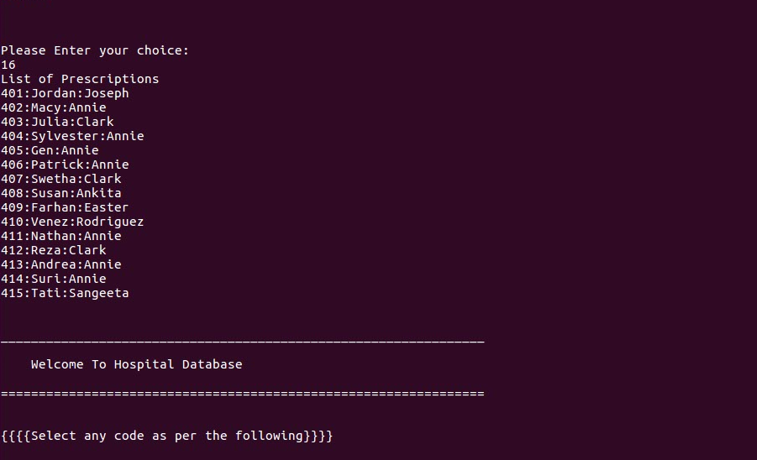

1. Insert prescription

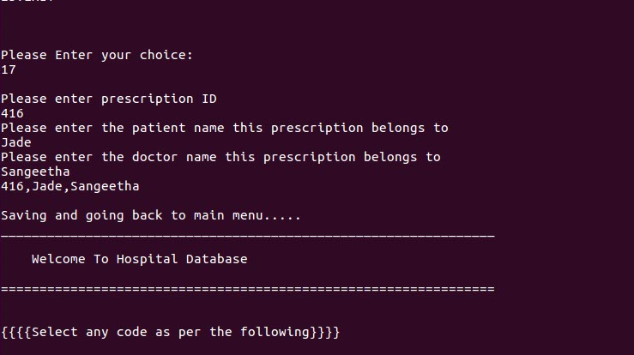

1. Modify patient information

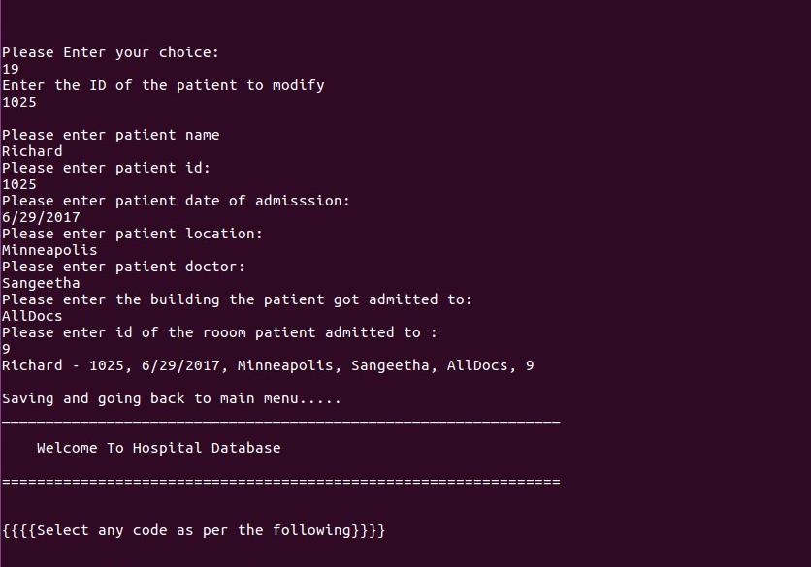

1. Modify hospital information

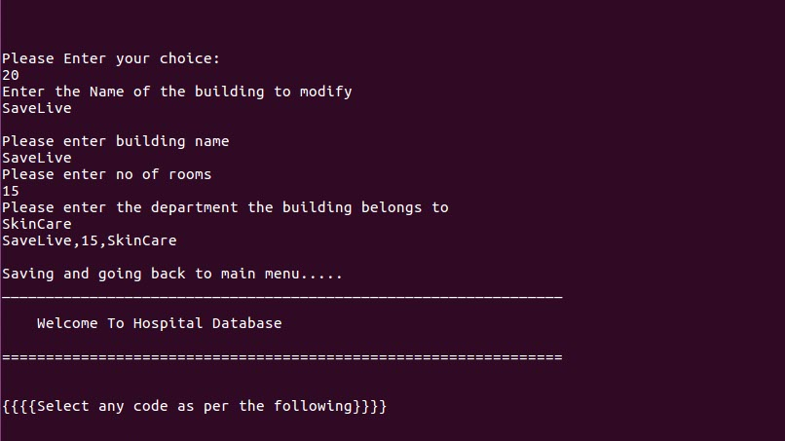

1. Modify room information

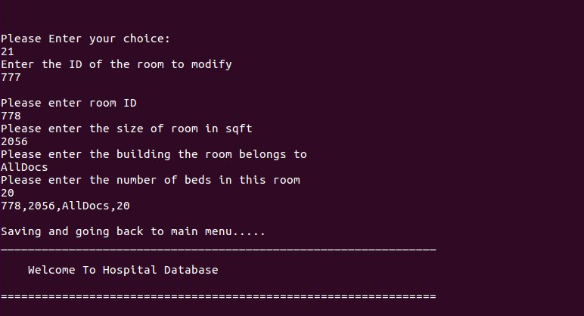

1. Modify doctor information

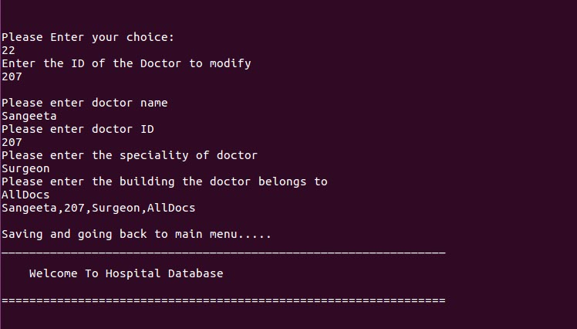

1. Modify pharmacy information

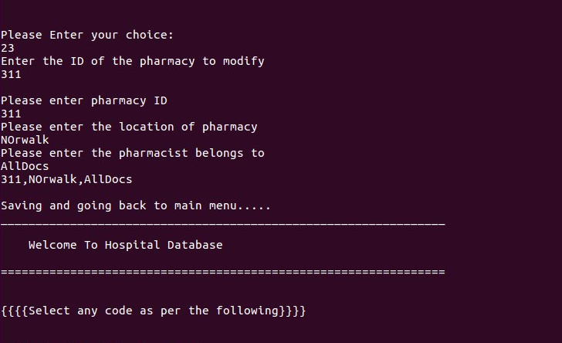

1. Modify prescription information

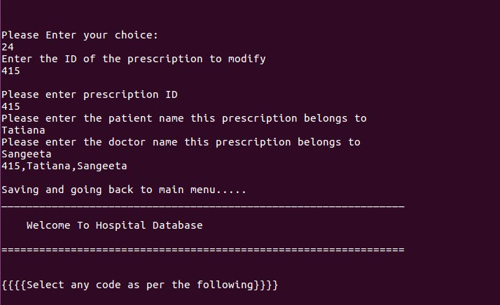

1. Exit

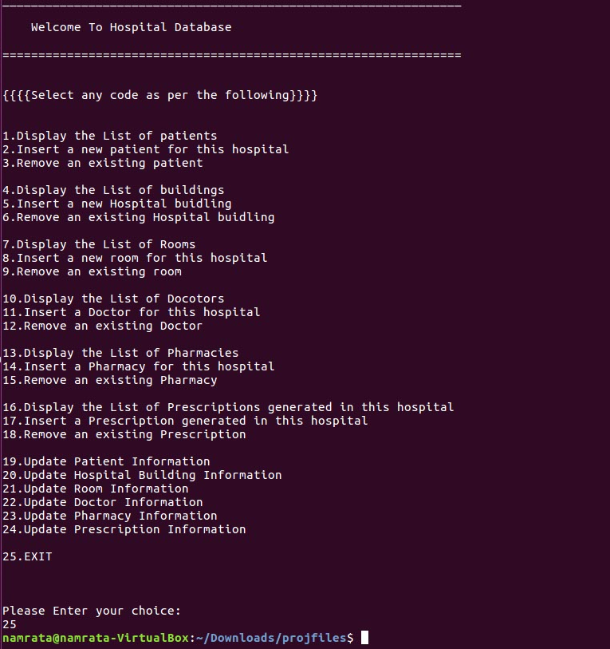

List of Queries:

1.list all the patients records registered after the id number 1015   
2.output the number of patients admitted in DexterPLus Hospital in different locations   
3.print the list of patients that are prescribed by doctor Clark   
4.output the number of patients admitted in AllDocs Hospital   
5.print the list of patients that are prescribed by doctor Annie   
6.list of all patients from bridgeport   
7.Total number of patients residing in the budh bhawan   
8.how big is the hospital(No of hospitals)   
9.number of patients alloted in the hospital   
10.total area of the hospital(Addition of all rooms area)   
11.number of pharmacies that are established

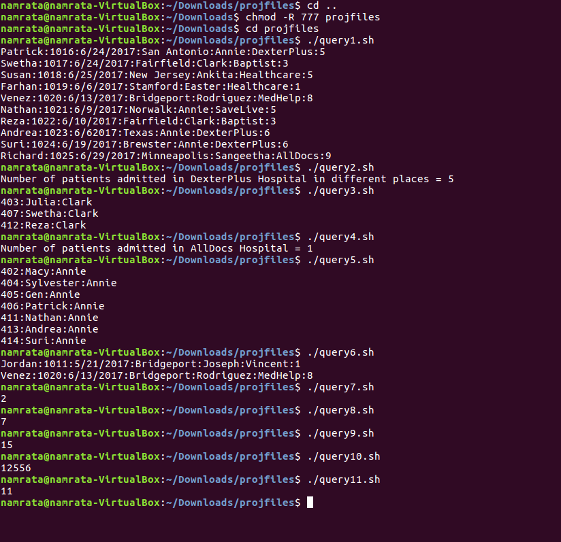

Conclusion:

Hence the Hospital Management system project with UNIX shell script gives a clear picture of the reports and data displayed as per the menu options selected.